Action Plan – seitechinternational.org.uk
- Google Page Speed Insights:
Currently, your page speed on Mobile is average. A higher score is better and a score of 85 or above indicates that the page is performing well.
Mobile:
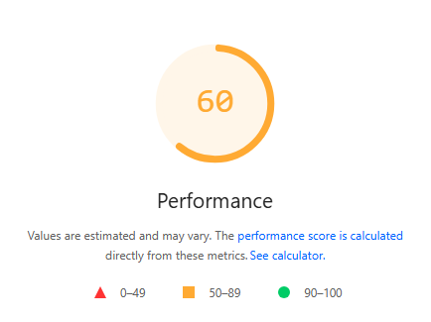

Desktop:

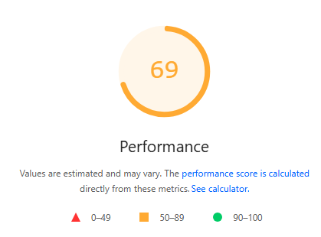

Solution: Please solve all the issue with the help of developer and improve the page speed. We need at least 85 or above score. If the page is not optimised it is likely to deliver a slow user experience. Please prioritize and apply the recommendations below.

- Largest Contentful Paint element
- Avoid large layout shifts
- Eliminate render-blocking resources
- Defer offscreen images
- Properly size images
- Avoid an excessive DOM size
- Reduce unused JavaScript
- Reduce unused CSS
- Minify CSS
- Avoid enormous network payloads

- Website coding

Great code has many attributes. It’s effective, efficient, maintainable and elegant. Code needs to be consistent and easy to understand. Your website coding is not SEO friendly. We have found 75 errors and 31 warning, Minify CSS & JavaScript issue in website. Please click on link below to check the errors and warnings in detail:

https://validator.w3.org/nu/?doc=https%3A%2F%2Fwww.seitechinternational.org.uk%2F

Solution: Please discuss these html error with your developer as he can help you resolve them.

- Create a /thank-you Page: Please add a thank you page to the website and redirect all the website forms to this page once the visitor successfully fills it. This will help to track how many visitors are filling the forms successfully.

- FAQ: Add FAQ section on home page on the website. Frequently asked questions, or FAQs as they are known, are a great way to improve your customer's experience of your website.

- Floating Contact Form, Call: Add floating form and tabs on any side of your website to help your visitors contact you and easily find your Facebook page, YouTube channel, open hours, address, phone number, email or any other important business information.

- Webpage Content – We will share content requirement sheet to create new web pages to target the keywords.

- Blog page: Need to add blog section on the website and add blog posts monthly basis related to services and keywords on the website blog.

- Contact Form Issue: The contact form on the Contact page is not redirecting to the thank You page after submission. Additionally, the tick mark (checkbox) option is not working properly. These issues need to be fixed.

- Footer Information: Add the company address, email, and phone number in the website footer for better trust signals and contact accessibility.

- Homepage Services Section: Add a dedicated Services section on the homepage, including target keywords for better SEO impact.
- Course Page Issue: Many course pages lack descriptions and images. Please add them to enhance user experience and improve search performance.

- Canonical Issue: Both the www and non-www versions of the website are currently accessible. Please set up a redirect from the www version to the non-www version to avoid duplicate indexing.
- Duplicate Content: There is duplicate content on the Compliance Services pages of both websites:
www.seitechinternational.com and www.seitechinternational.org.uk. Please resolve this issue.
- Google Tag Manager Issue: The Google Tag Manager code has been incorrectly replaced on the website. It needs to be fixed with the developer's help. Ensure that the line:
“Paste this code immediately after the opening <head> tag:”
Currently visible in the header section of every page.

- New Page: For targeting the keywords in a better way and to make the strength of the site better, we suggest you to create a new page for your website. New pages with relevant content and product information will attract visitors, increase the strength of the website and also be a great help for SEO work.

For example:
https://seitechinternational.org.uk/page/contractor-site-safety-inspection

